# **AC POWER ADAPTER CONTROLLABLE BY BLUETOOTH OR WI-FI REPORT**

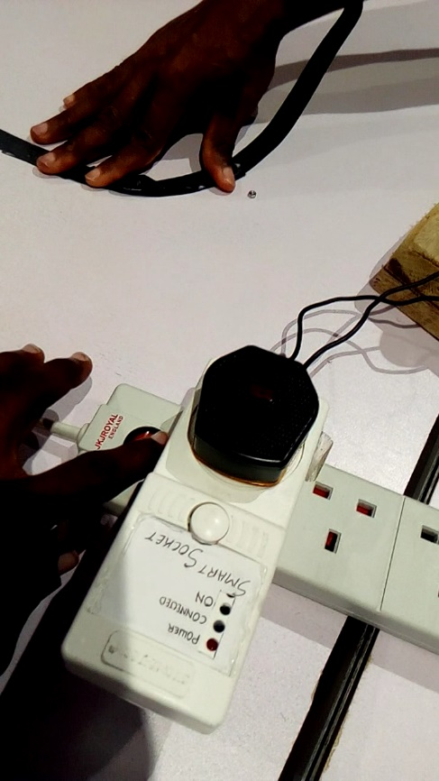

## RESEARCHERS

* Testimony Adams
* Opeyeoluwa Olanipekun

## SUPERVISOR

* George B. Okoroafor

## PROJECT DURATION

* Two months

## PROJECT CODE

* A010

# PROJECT DESCRIPTION

This project is designed to modify an already existing AC Power adapter and improve its features such that any device powered through it can be controlled from a mobile device using Bluetooth or Wi-Fi.

# PROJECT OBJECTIVES

* The Adapter should be controlled using a mobile device via Bluetooth or Wi-Fi from anywhere in the world.
* It should accommodate 13 amps of current and 240V ac, 50Hz.
* It should be controlled manually and automatically.
* The operation of the device should not be hampered by power outage.
* The hardware should possess friendly aesthetics and easy user experience.
* A notification should be sent to the phone of the user to alert on restoration of power from the national grid.

# PROJECT COMPONENTS

* Node MCU
* Relay
* Wires
* Casing
* Mobile device
* LEDs
* AC to DC Converter
* 220Ω Resistors

# PROJECT TIMELINE

* Get familiar with Arduino board and IDE, Node MCU, Relay and HC-05
* Understand the workings of Blynk App
* Write code to power AC Adapter with Bluetooth and Wi-Fi
* Integrate working parts

# PROJECT DESIGN

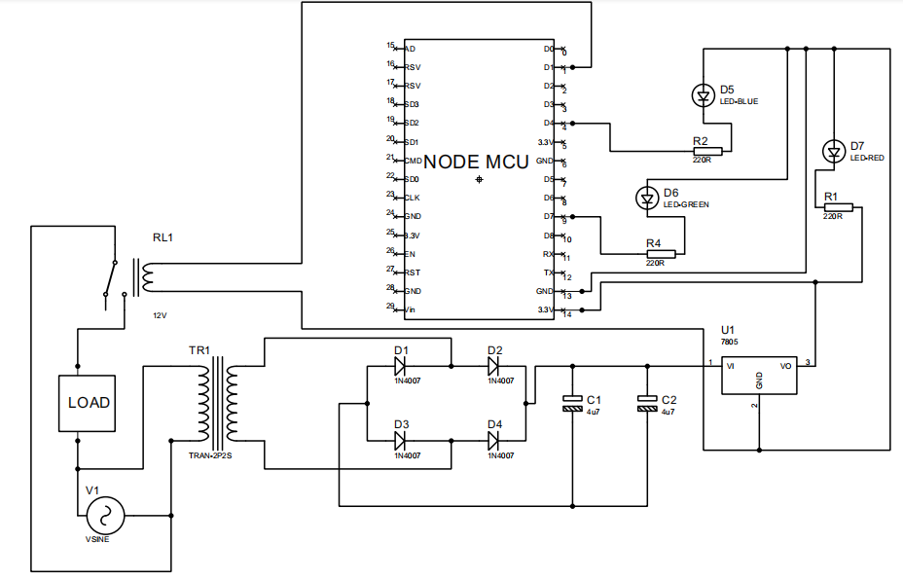

# PROJECT CODE

#define BLYNK_PRINT Serial

#include <BlynkSimpleEsp8266.h>

#include <ESP8266WiFi.h>

#define BLYNK_MAX_SENDBYTES 1200

int relay = 5; //D1 Normally Closed with Load

int greenLED = 13; //D7

int blueLED = 2; //D4

char ssid[]= ""; //wi-fi name

char auth[] = ""; //authentication code from Blynk

char pass[] = ""; //password of wi-fi

BLYNK_WRITE(V1){ //virtual pin 1

int pinValue = param.asInt();

if (pinValue==1){

digitalWrite(relay, HIGH);

digitalWrite(greenLED, HIGH);

Blynk.email("your_email@gmail.com","Smart Socket ALERT!!","Device is On");

Blynk.notify("Smart Socket ALERT- Device is On!!");

}

else{

digitalWrite(relay, LOW);

digitalWrite(greenLED, LOW);

Blynk.email("your_email@gmail.com","Smart Socket ALERT!!","Device is Off");

Blynk.notify("Smart Socket ALERT- Device is Off!!");

}

}

BLYNK_CONNECTED(){

Blynk.syncAll(); //to send the latest values of all values

}

void setup()

{

// Debug console

Serial.begin(9600);

pinMode(greenLED, OUTPUT);

pinMode(blueLED, OUTPUT);

pinMode(relay, OUTPUT);

Blynk.begin(auth, ssid, pass);

Blynk.notify("Smart Socket ALERT- There is Power!!");

digitalWrite(relay, LOW);

WiFi.begin(ssid, pass);

}

void loop()

{

if (WiFi.status()== WL_CONNECTED){

Serial.println("WiFi connection succesful");

digitalWrite(blueLED, HIGH);

}

else{

Serial.println("WiFi connection lost");

digitalWrite(blueLED, LOW);

}

Blynk.run();

}

# WORKING OF THE BLYNK APP

Blynk is a new platform that allows you to quickly build interfaces for controlling and monitoring your hardware projects from your iOS and Android device. After downloading the Blynk app, you can create a project dashboard and arrange buttons, sliders, graphs, and other widgets onto the screen. Using the widgets, you can turn pins on and off or display data from sensors.

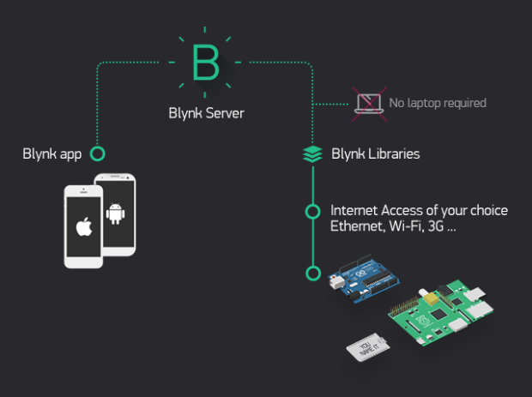

The Blynk app was interfaced with the code by downloading the library in Arduino and including the library in the code.

# PROJECT WORKING PRINCIPLE

* When there is power, the red LED will come on and a notification will be sent to the user that “There is power”.

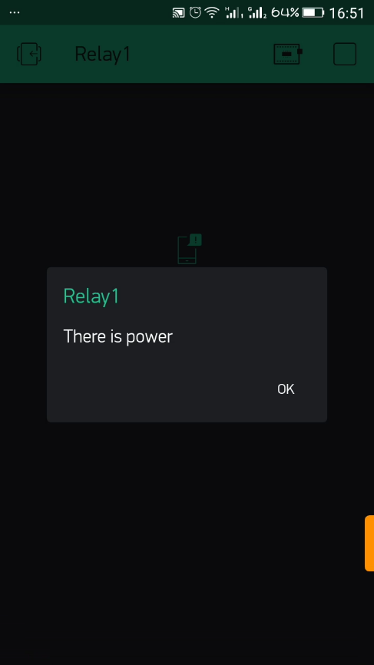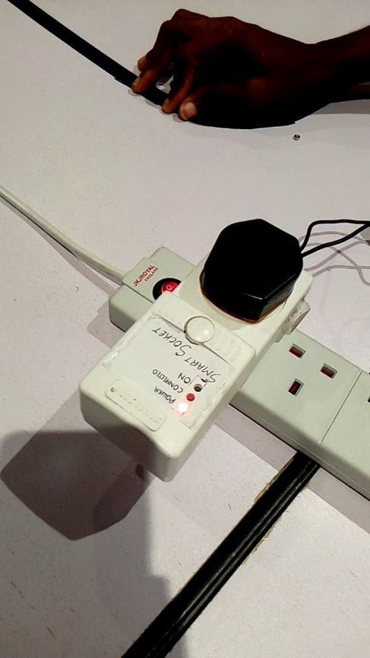

* When the device is connected to the wi-fi network, the blue LED comes on and if the wi-fi disconnects, a notification is sent from Blynk to the user.

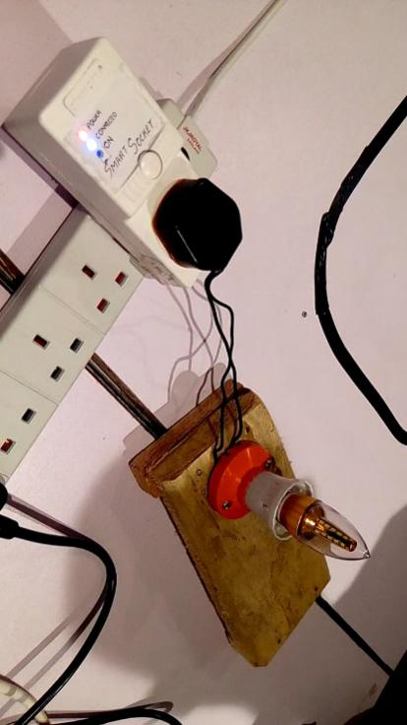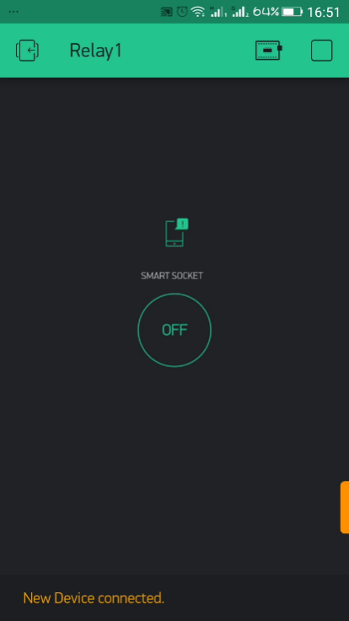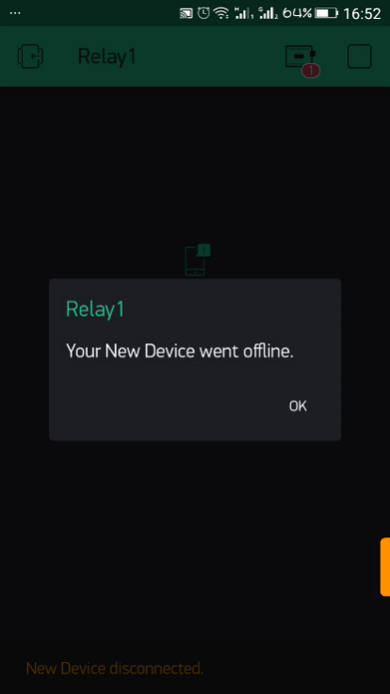

* When the device is powered on from the Blynk app, the green led comes on and whatever is connected to the socket.

